MATLOCK AREA u3a

ANNUAL REPORT 2023

Published by Matlock Area u3a

March 2024

Message from the Chair

Welcome to another annual report for Matlock Area u3a. The last year has been an active year for us, with new groups being formed and established. The once- a-month meeting in the Football Club has become a focus point, with guest speakers on a wide range of topics as well as coffee and a chat. These have been a mixture of external speakers and home-grown talent, such as the interesting presentation on DH Lawrence by Steve Bailey, and the wonderful Christmas performance from the recorder group.
Thanks to all the committee, and to those who support in the background running the website and our Beacon managerial support. The hard work of these people help to keep us running smoothly and legally. Thanks also to all the coordinators who have volunteered their time to run groups and to organise activities.
The u3a is a self-help organisation and can only continue to function if you, the members, contribute. Please consider if you can offer to help, on the committee or as support for events. There are members on the committee who have served for many years, but we lost a committee stalwart in Linda Wilson when she moved to Wales.
We have many different groups but if you can’t see a group that serves your interest then why don’t you start one!? We can give lots of help for new groups to get established, to advertise for new members and to help financially with initial start-up costs. Neighbouring u3a’s have groups that range from craft groups to adventure sports, belly dancing or a ‘moto’ (members on their own) group.
You will see that among the motions for your approval at the forthcoming AGM is a proposal to amend our constitution. On the advice of the national u3a we adopted emergency measures to allow us to use remote and email voting for your approval during lockdown. The committee have looked at the constitution, drawn up by the founding members in 2007, and updated it to reflect modern communication methods. We need your approval for any such changes and hope you will give it.
I do hope I will see many members in person at the AGM. We need to be quorate so that the hard-working members of the committee have your support for another year - without an active committee supported by all of you, the members, Matlock area u3a could not continue. If you cannot attend in person do please vote to support the committee and the proposals we have put forward.
Liz Walker

GROUP REPORTS
Archaeology

A small number met in April to form a new Archaeology Group to bring together those who had an interest in visiting local sites. Having planned our meetings in April, the first visit was to Stanton Moor in May. With over 200 scheduled monuments recorded it was a fascinating if rather frustrating visit trying to understand the landscape and where the monuments were located. The second visit in June to Arbor Low was more familiar territory; a glorious sunny day meant we lingered among the stones. In August we visited Lea Wood and heard about the excavation of the Q pits from a member who took part in the last dig. In September we visited the site of Fin Cop hillfort at Monsal Head. In each of our visits a different member of the group leads, much of the benefit though is in the informal conversation during the site visits and then afterwards over some refreshments. From the first we were determined that the group, although knowledgeable, shouldn't be overly academic, rather we aim to be friendly and encourage all views and opinions. Some of the group are actively involved as volunteers at various sites and bring this current knowledge into our discussions. The group welcomes new members and anyone interested should contact the co-ordinator.
Cameron Butland
Art Appreciation
The Art Appreciation Group continues to thrive, welcoming new members during the year. The monthly meetings continued at the Whitworth Institute embracing a wide range of subject matter from local sculptor Ronald Pope to art for the Festival of Britain to Joseph Wright of Derby. We also got out and about having a successful excursion to Derby Museum and Art gallery for a guided tour of the Hogarth exhibition. Anne Oldfield stepped down as coordinator of the group. Anne and her husband John have been stalwarts of the group and its success has been largely down to them.
Patrick Wright
Art

The Art Group has enjoyed another creative year based at Turner’s Art Supplies in Lower Lumsdale. Attendance has been excellent – so Turner’s bought us an extra table, four new chairs and a second kettle! Several members have exhibited their work as part of a group, others simply enjoy making and discussing art in good company. Sadly we have lost a long-term member who has moved away, and others are less able to attend due to care responsibilities or health issues, so we are still pleased to welcome new members to the group

Ruth Gordon

Book 3

Book Group 3 has been meeting on the first Friday of the month for the past year. There are twelve in the group which, conveniently, means that we each host once per year and it is the host’s job to choose the book for that hosting. We've had a very varied and interesting year, varied in time and place, ranging from the English revolution in the seventeenth century (The Smallest Man) to pre-war Austria (The Tobacconist) and modern day Antarctica (Lean Fall Stand). At the end of the year we have a vote for our favourite book and this year Where the Crawdads Sing won convincingly. Discussions are lively (we never agree) and often go on to solve the world's problems.

John Mann

Bowls 2

April 2023 saw the start of the tenth season for Bowls Group 2 based at the Matlock Bath Bowls Club. We have maintained a steady membership and everyone has enjoyed sociable but always competitive games in a relaxed and friendly environment. The new season will start in April, dependent upon the weather conditions, so watch the website for further details. There are vacancies for next season so if you are interested in playing please get in touch.

Mike Frosdick
Bridge
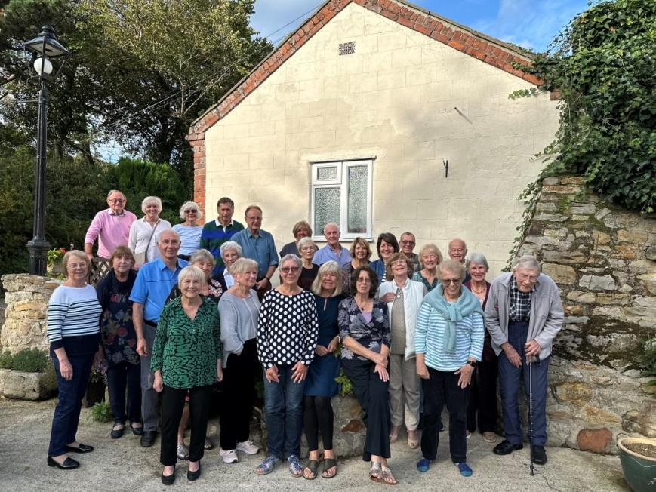
In the past year the Bridge Group has had a few changes. In June Roger Keeling retired as Coordinator, a role he had undertaken for 10 years. He has been replaced by Rachel Jenkinson and Roger Spells. We have around 65 members and we play at the Matlock Football Club every Wednesday. The group continues to thrive with the Frank Hemming Annual Trophy being competed for each year, along with an annual 2/3 days away trip, usually to Yorkshire, which is lots of fun and where some bridge is played. We also have 1 or 2 buffet lunches held after a bridge session every year which are always appreciated. This year we ended the year with a Fun Bridge session organised by one of our members where much hilarity ensued and was enjoyed by all.
Rachel Jenkinson

The Bridge group

Classic Novels
Classic Novels are those having value and relevance that endure through generations to the present time. Our group met monthly throughout the year to discuss choices which included Brave New World, Barchester Towers, Precious Bane and Frankenstein. Views of the novels usually vary and have given rise to enjoyable discussions. The group has welcomed several new members during the year.
Peter Hales

Creative Writing

The Creative Writing Group restarted in October, so have had three successful meetings: a topic is chosen and each member writes a piece based on the topic. It was been very entertaining seeing how people look differently at the given topic. We are looking forward to continuing success in 2024.

Susan Tomlinson

Current Affairs 1

﻿Current Affairs 1, which meets in each other’s homes, had another active and stimulating year, despite the rather depressing nature of the current affairs environment. Each month a member introduces a previously chosen subject, which we discuss at length before moving on to current news. Topics have included the NHS, the Climate Crisis, Private Education and AI. Additionally we held a successful annual lunch, with partners, at the Woodyard in Bakewell and were unable to avoid discussing, yes you guessed it, current affairs. On a sad note we remember the passing of Ros Bourne, who was the previous very competent organiser of our group. We look forward to an interesting 2024, which we suspect will be dominated by the party political election ‘battle’: much to discuss.

Tony Symes

Current Affairs 3

Our group meets on the last Thursday of the month to discuss current news, events and issues from around the world. The last year has given us plenty to discuss, but more importantly the opportunity to read around those stories that have piqued our interest. The challenge is also to find different news outlets from around the world to give different perspectives to our chosen topics. Popular themes have been the state of our waterways, how wildlife is being impacted by relaxation of environmental controls, budgets and the autumn statement, proxy wars and many others. Although the news can be concerning and sometimes depressing we introduced a ‘bring your own funny news story’ item to each meeting to lighten the mood. The monthly meeting has provided us with a safe and non-judgemental environment in which to discuss current issues that are of interest to the group. 2024 promises to be another year when we will have no shortage of current affairs to discuss.
Tracy Sims
Family History
We continue to meet at 2pm at the Derbyshire Records Office on the 3rd Wednesday of the month. For the first time we have had to pay for the room; on average attendance has been 8. Topics have varied from bastards in the family to finding who has gone back the furthest: one went back to the fifteenth century. One speaker of note was John Titford, writer of many books on family history. Our first meeting of the new year will be a day out at Chesterfield Library.
Trevor Boam

French Conversation
During 2023 the decision was taken to change our venue. We moved from All Saint’s Church Hall to the library at St Elphin’s, with the expectation that participants will use the Bistro at St Elphin’s after each session. The transition has been popular, and numbers attending have increased over the year. We continue to meet on the last Tuesday of the month, 1:30 – 3:00pm. Group members are emailed with a suggested topic during the week before each meeting, giving those that choose to time to prepare.
Some of the topics covered during 2023 were Technology, The Generation Gap and Halloween. Our conversations start around these prearranged topics but enjoyably go off in many directions. We endeavour to give everyone the opportunity to join in. The focus of the group is to practise speaking and listening skills in an informal atmosphere, where understanding and being understood rather than technical accuracy is the focus. So far, we are achieving this aim. A list of resources that can be used between sessions has been developed, these are available via email. It is our intention that the group continues to flourish in 2024.
Candy Jones
Gardening
The Gardening Group has had fewer visits than usual this year, but highlights included a coach trip to RHS Bridgewater, and a visit to Derby to see the wonderful rhododendrons. The coordinator is Liz Walker, who is also Chair and Newsletter Editor, and the group would benefit from a new coordinator to help move things forward. New members are always welcome.
Geography
After establishing a routine of outdoor activities during Covid-19 which continued into the less restrictive regime which followed, the Geography Group continued to get up close with its subject during 2023. Most of our meetings explored a specific locality in the Matlock area, studying some of the distinctive features around us and trying to understand some of our landscape better. We did try to have some indoor meetings during the year but attendances benefitting from indoor comforts were considerably less popular than when we ventured out and about. As a result, we didn’t have any meetings during November or December but shall resume in January – although that meeting will be in the warmth of one of the member’s homes rather than facing up to what could be a rather bleak winter morning. 2024 should again give us opportunities to widen our local understanding and we would welcome anybody who would like to join us. Even though much of our focus is local, the world is our oyster and there’s plenty more to look at in the coming year.
Keith Downing
History 1

History Group 1 drew to an end of three years of studying 'The Victorians to the Edwardians' in which we covered a wide range of topics, including politics and politicians, technology, the arts and much more. In May we marked twenty-first century history with a confection of short pieces on the theme of 'Coronations'. We ended the year with an idiosyncratic, but informative and amusing quiz.

Janet Pidgeon

History 2
History Group 2 continued its exploration of the eighteenth century worldwide during last year. We usually have 11 members with a few coming and going each year which keeps us refreshed. We are not strict about the topics and some of us stray into other periods e.g. The Romanovs and St Helena Island. We sometimes feature individuals including Josiah Wedgewood, Shelley and his circle and Benjamin Franklin. Alternatively we explore more widely e.g. Chantry Chapels and Georgian music. We also managed an outing to All Saints Church, Ashover and an historical tour of the village.
Helen Boocock
History 3
Meeting monthly, we have continued to explore nineteenth-century history worldwide, gathering in members’ homes on the first Monday to consider two subjects each time. Topics have ranged widely from John Ruskin to Derbyshire’s Murder Stones, Crime and Punishment, Gertrude Bell, Oscar Wilde, The Rochdale Pioneers, the Crimean War and everything in between. There seems to be no limit to the interesting subjects available for study. During the year we also held a study field trip to Halifax, a Christmas meal and summer barbecue, all enjoyed with partners.

John Entwistle

History 5 – the history and culture of Derbyshire, Yorkshire and Nottinghamshire
The group now has nearly 50 members and we have an attendance of between 25 and 35 members per session. The ten meetings in 2023 covered: the impact of quarrying on the lives of people in our local communities; the life of Riber Castle (private house, boy’s school, food store, wildlife park); old films of the Peak District and Glossop; Maria Branwell, mother of the Brontës, followed by a talk on the Brontës, who used to walk around their writing table reading their scripts aloud to their sisters. We heard about the lace trade and bobbin lace making, with a demonstration of the art. Another session looked at the roles that the presenter’s ancestors had played in the somewhat grander lives of the Devonshires and the Fitzwilliams. The meetings stir memories that take on a richness as we hear about the lives of others which, in turn, trigger our own reflections of our pasts, the place where we live, and events that we had forgotten such as the great snows of 1947.
Roger Clough
International Folk Dancing
The International Folk Dancing Group is thriving and continues to meet each Friday morning in All Saints Church Hall, Matlock. We have 28 enthusiastic members on our register now, the majority of whom turn up regularly each week to take part in the wide variety of dances on offer. Last year we held a special event to celebrate Janet King’s 80th birthday and had a very enjoyable morning full of great party dances, led by Janet and Gill Seller. Janet is a founder member of the Matlock u3a and has led our group for many years now, teaching us an enormous number of folk dances from around the world and providing us with some entertaining weekly sessions. She has now taken a step back from full responsibility, and we are grateful that Gill Seller agreed to take over as the main leader of our group. We are happy to report that Janet King continues to lead many of our dances alongside Gill and other members of the group.
Hilary Casey
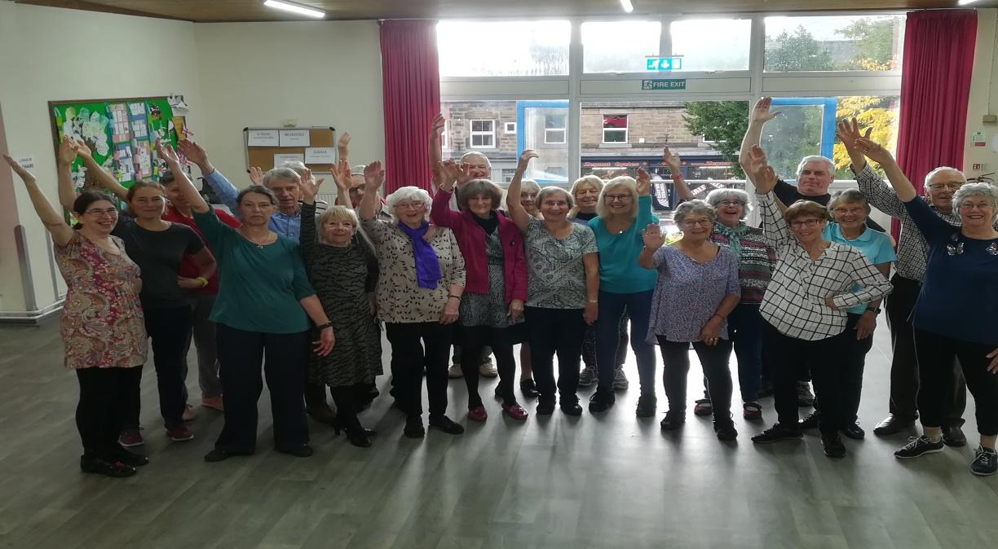
International folk dancers

Jazz

Our activities are simple and extend no more than listening to and discussing the cornucopia of jazz and blues sounds throughout the twentieth and twenty first centuries. That, I believe, is appreciation.

Mike Reuss

Life Writing
A small group are currently exploring the viability of a new group that will help members write their own life story. Everyone has different reasons for wanting to write their life story and so far there have been many suggestions about how best to do it. There are no right answers and we are all learning about the possibilities and opportunities from each other. We are a small group which meets at each others' houses on a rotational basis, usually on the first Wednesday morning in each month. So far we have had two meetings and discussed our individual aims and objectives, as well as started to think about how we will structure our work. Although members work at different speeds and in very different ways, the discussions so far have shown that we can all benefit from the wider input and ideas of others. If you are interested in joining the group then please contact David Gray at d.gray811@btinternet.com.

Local History

The Local History Group have had an interesting and varied year, we started in January hearing about Murder Stones; old pubs of Matlock and Christmas/New Year traditions. At further indoor meetings we saw how the Matlock cable cars were built and photos of where the film Women in Love was shot; the development of the turnpike road system in Derbyshire; Cromford Canal; the history of Rowsley and Wirksworth from Prehistory to 1066, ending in December when most of those present gave short talks on various aspects of local history. Outside events have taken us to Crich; High Peak Junction; Winster; Woolley Moor and Matlock Bath. Thank you for all who gave talks both inside and outside and thanks to all who came along to meetings.

Susan Tomlinson

THE LUNCH CLUB
Food, Glorious Food! Laughs, Glorious Laughter
Talk Glorious talk, that’s what we’re after!
Monthly we meet and eat, with different menus
Leaders with care selecting interesting venues!
Sometimes we pay not much: sometimes a lot
Standing no messing if the food’s not really hot!
Join up to twenty four, sometimes it’s bigger
Once for a happy day - forget your figure!
(New members are welcome, although there is a short “Standby List” to join the group: for more information email the Co-ordinator, John Anderson on jandganderson@binternet.com with brief details and contact number)

Mah Jong
Although Mah Jong can be played electronically, the group is intended for those who wish to play using the traditional tiles. The Mah Jong Group meets every Friday evening from 6pm to 9pm, with a short refreshment break at the mid-point. This typically allows time for between 10 and 12 individual games and socialising in the break.
In 2023 the group met 48 times, with a typical attendance of between 6 and 12 members. We had a mixture of novice and experienced members and continued to welcome newcomers. The group would like to thank group members Christine and Mike Tongue for the use of their premises, the Family Tree at Whatstandwell, in 2023. Also Debbie and Colin Davis played host, when the Family Tree was unavailable.
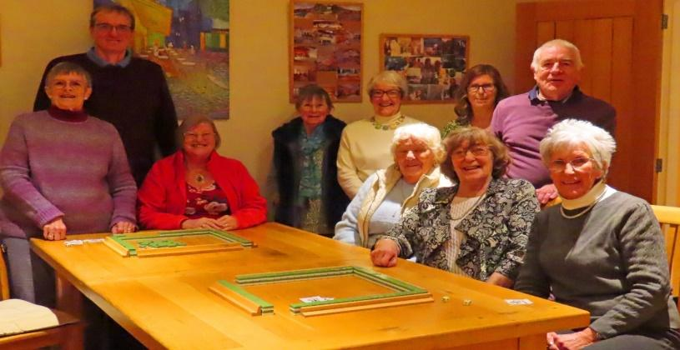
The Mah Jong Group January 2024
With Chinese characters in abundance, the game can look complicated at first sight, but the basics can be learnt quite quickly and the group has a number of experienced members who are able to provide support and guidance. New members are welcome to come along and join the group, whether novices or experienced players.
Colin Davis
Mindfulness and Meditation
The Friday group continues to meet on the second and fourth weeks each month. We have moved to the Upper Room at Tansley Village Hall. In September we recognised that we had reached the limit for a comfortable size group. Not wanting to disappoint people who continued to enquire about joining, we offered a second group, also fortnightly, meeting on Wednesdays in the intervening weeks. This group has been set up initially for nine sessions to follow an introductory Mindfulness programme. Having three co-ordinators works well and we encourage all group members to contribute to the group.
Judith Holt
Recorder Group
The Recorder Group has welcomed another member this year; we are now 15. In the past couple of months we have given three recitals for community groups – testament to our growing confidence to perform in public! We continue to enjoy meeting weekly throughout the year, playing a variety of musical styles with different levels of complexity.
Karen Hale

Rumikub

The Rummikub group has only been running for a year﻿, but it has been regularly attended by at least 12 members on alternate Thursday afternoons. The venue is in the centre of Matlock, so it is easy for most people to access and everyone is enjoying the group.

Merelyn Gamby

Scrabble

Having set up the group in September, we quickly managed to get together enough members to make it viable and held our first meeting in November, which was well attended and very enjoyable. December was the same. I am now having to operate a waiting list as no more room at the inn at present!

Pauline Shipway

SciTech
We held 8 two-hour sessions throughout the year with members of the group making presentations and leading discussions on a wide range of topics including: memory in plants, global warming, electric vehicles, heat pumps, eco-materials, and cement manufacture. At each session there was an opportunity for further informal discussions over tea and coffee. The number of members attending ranged from 5 to 20. We meet at St Elphin’s Park retirement village and thank them for their hospitality and help with setting up the room.
Mike Steel

Singing for Pleasure
The Singing for Pleasure Group met once a month throughout 2023. The group usually had around 27 singers each time, though the actual members present would vary month to month. We sang music belonging to several genres including folksongs, songs from the twentieth century, rounds, partner songs and old favourites. We were usually accompanied by two excellent pianists who kept us up to speed and in tune. In November we sang with a jazz saxophonist which was extremely enjoyable and a new experience for all of us. We hope to repeat this in 2024, as well as expanding our repertoire and continuing to sing for pleasure.
Hazel Finch
Shorter Walks
The Shorter Walks Group meet on the 2nd Saturday and 3rd Wednesday each month for a walk of between 3 and 5 miles. Walks are led by volunteers within the group and usually number between 6 and 10 people. Venues for the start of walks this year have included Black Rocks, the Stone Centre, Rowsley, Carsington, Stanton Moor, Calver, Holymoorside, Masson Hill and Chatsworth. Unfortunately, we have had to cancel some walks recently due to inclement weather and dreadful conditions underfoot. Bring on summer! I shall be away from the end of February for just over a month, so any enquiries can be addressed to Hilary Essen at this time.
Debbie Davis
Tap Dancing

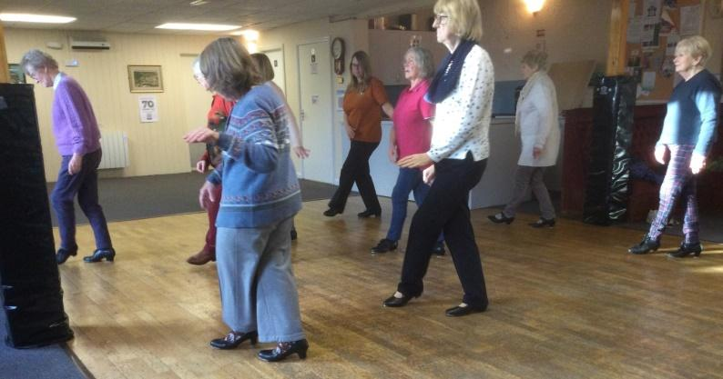
The Tap Dancing Group (currently numbering 12 members) has met weekly during 2023, apart from the month of August, when we break for the summer. As well as regularly revising all of our older routines, we have introduced several new routines mainly to Broadway tunes. Two of these involved the use of canes, a new skill for the group. We then graduated to umbrellas for “Singing in the Rain”, a long and complicated routine involving many changes of position. It proved tricky at first but with perseverance we are almost there. We also developed a new routine to “I got Rhythm”. We enjoyed a summer party in July before we broke up for the summer and a Christmas fuddle in December. We look forward to more new routines in 2024 and more parties!
Tap dancers in action

Gwynneth Beck

Wednesday Painting Group
We have welcomed several new people this year but sadly our talented member, watercolour artist Sue Warner died in October. We miss her joviality and the help she gave to others. Each month we have a selected topic and members can submit a piece of work based on that theme. The subjects this year have included ‘Essence of Japan’, ‘Bake off’ and ‘Regal Ceremony’. We have enjoyed two printing sessions using our small printing press, one using collagraph and the other linocuts. The results were very interesting.
Gill Oldroyd ﻿

Other Groups
Book Group1, Bowls1, Boules, Table Tennis, Poetry Appreciation, Wine Tasting, Wildflowers.

For information on Matlock u3a, its group activities, general events, contact email addresses and membership visit:

www.matlockareau3a.org.uk

TRUSTEES OF THE MATLOCK AREA U3A AND MEMBERS OF THE MANAGEMENT COMMITTEE 2022-23

NAME | HOME LOCATION | COMMITTEE ROLE | ELECTED UNTIL
Gill Needham | Matlock | Membership Secretary | 2023
Brian Williamson | Matlock | Treasurer | 2024
Liz Walker | Darley Dale | Chair | 2023
Hilary Essen | Matlock | Group Liaison Officer
Helen Boocock | Matlock | Secretary | 2023
Cameron Butland | Matlock | Ordinary Member | 2026
Stephen Bailey | Whatstandwell | Publicity Officer | 2024
Liz Mann | Matlock | Ordinary Member | 2024
Merelyn Gamby | Matlock | Ordinary Member | 2026
OTHER OFFICERS
Diane Frosdick | Matlock Bath | Beacon Administrator
Keith Bailey | Darley Dale | Equipment Officer
Mike Frosdick | Matlock Bath | Webteam
Dave Puxley | Matlock | Webteam

