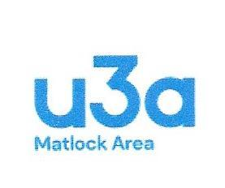
MATLOCK AREA U3A

TREASURER’S REPORT
Full Year 2022-2023

Attached is a summary of the Accounts for the full year 2022-3.
The figures here are provisional. Full year papers have been submitted to Coates and Partners (auditors) for review and should be available for the agm
In the main bank account, we currently have a balance of £16,072 but there is still an outstanding invoice from the football club which is likely to be in the region of £260. There are no other significant outstanding liabilities. Overall, we have a balance of £19,148 across all 3 bank accounts.
Membership fees for 2022 totalled £6,448 and we have already collected £4,697 for 2023. The financial year end of January 31st, with subscriptions coming in from January 1st for the following financial year presents an unnecessarily complicated end to the financial year for the treasurer. The committee have therefore decided to delay the payment of the subscriptions for 23-24 to come into effect after the previous financial year has ended
The main expense from our account is to the Third Age Trust, the central u3a body, which amounts to £4225. This covers the insurance of our activities and groups, the support that the central office gives us, and the Third Age Magazine. We do pay extra for this per head.
The committee expenses amount to £837, most of which is in printing and postage costs to keep those with no email in touch.
Significant transactions include deposits for the Bridge group trip to Cober Hill and the Garden Group visit to RHS Bridgewater. These visits and activities are self-financing. We do subsidise the coffee morning room hire, although the speakers have been financed from takings.
Nothing has materially altered the projected spend, meaning that we remain in good financial shape, with a closing balance at present £2400 above last year. The committee is therefore in a position to assist groups with the purchase of equipment if an application is made to them.
Brian Williamson

