MATLOCK AREA u3a
ANNUAL REPORT
Jan2022-Jan23

Message from the Chair.

It is lovely to see Matlock Area u3a emerging from the pandemic. Not unscathed, but optimistic, I hope!
We have over 650 members which shows the strength of our groups, and continue to attract new members. Some groups have folded since the pandemic, but new groups are emerging, such as the new Rummikub group
Thanks are due to all those who have volunteered their time to run groups and organise activities. The coordinators, the committee, and those who support in the background running the website and our Beacon managerial support have all helped us to get through the last couple of years.
The u3a is a self help organisation and can only continue to function if you, the members, contribute. Please consider if you can offer to help, on the committee or as support for events. There are members on the committee who have served for many years. Could you relieve them?
A high spot of the 2022 was the walking baton relay organised by Linda Wilson. Collaboration with the other u3a’s in Derbyshire through the Derbyshire network has opened up new options and the possibility of wider group links in the future. It was a shame that the picnic we had planned to meet the baton in the park had to be cancelled due to the death of the Queen. This has led to more cross group ‘walk and talks’ where members show off the highlights of their town or area.
Another highlight was the History day where all the history groups worked together presenting different aspects of their studies. Collaboration between groups definitely increases the social aspects of the u3a.
I do hope I will see many members in person at the forthcoming AGM. Zoom has had its place but it is no substitute for person-to-person contact! We need to be quorate so that the hard working members of the committee have your support for another year …without an active committee supported by all of you, the members, Matlock area u3a could not continue.
Liz Walker

Groups News for 2022

Details of all the current Matlock Area u3a Groups can be found at:
https://matlockareau3a.org.uk/groups-list
Website: https://matlockareau3a.org.uk

Art Appreciation
In January and February 2022 the group was still meeting once a month on Zoom, which had helped to hold us together during the pandemic. In March we resumed our face-to-face meetings at the Whitworth Centre. After fifteen years of meetings, with many of the original members, the group still manage to discover new aspects of art to explore. We have been pleased to welcome four new members in the last three months.
During the past year we have covered a range of subjects including female Impressionist artists and American painters. We have explored the work of some more recent artists such as Paula Rego and Cornelia Parker. We have looked at the work of Banksy and the development of street art particularly in Port Talbot. In the coming months we are looking forward to presentations on the work of Auguste Rodin, Eric Gill and Ronald Pope. As coordinator I am grateful to the members of the group for all their support and hard work in researching and preparing presentations.
Anne Oldfield
Art
Once Covid restrictions eased the Art Group were eager to get back to regular meetings. We had to find a new venue, as the Matlock Scout and Guide hut was not ready to re-open. Turner's Art Studio at the bottom of Lumsdale has many advantages – a purpose-built studio, no set-up time needed and a handy art supplies shop next door. Since moving, attendance has been good and we felt confident to drop our weekly fee from £4 to £3 in February 2022. Over the last year we have welcomed several new members who have brought fresh viewpoints and enthusiasm. We have had fun, shared knowledge, argued about perspective and enjoyed each others' work at our monthly mini exhibitions.
Ruth Gordon
Bowls
April 2022 saw the start of the ninth season for Matlock u3a Bowls Group 2, based at the Matlock Bath Bowls Club. This year we moved our session time to Monday afternoons to minimise the dew and worm problems that can occur early and late in the season. In addition we were also able to reintroduce the welcome refreshment break following the relaxation of Covid restrictions. We have maintained a steady membership, and everyone has enjoyed social but always competitive games in a relaxed and friendly environment.
The new season will start in April dependent upon weather conditions, so watch the website for further details. There are vacancies for next season so if you are interested in playing please get in touch. Do not worry if you have never played before, many of our current members had no experience when they joined and have progressed to playing regularly in the local friendly league. Training, encouragement and all equipment can be provided; all you need are suitable clothing, flat shoes and a sense of humour.
Mike Frosdick
Bridge
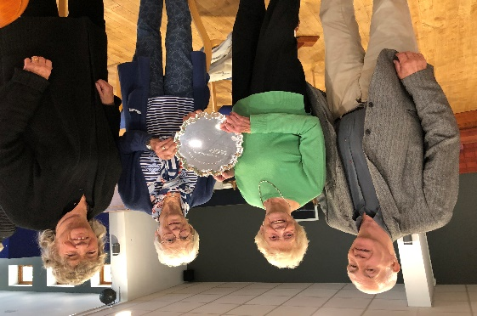
During the pandemic, we were, fortunately, able to continue to play bridge online. However, with restrictions having been relaxed, the group has very much returned to its pre-Covid operation. We regularly welcome 40 members (10 tables) to our weekly Wednesday morning meetings at the Football Club. During the year we were able to enrol six new members.
In September, we held our annual competition for the much-coveted Frank Hemming Salver, donated to the Group by Frank, one of its founder members. A nail-biting morning’s play was followed by the award of the prestigious gleaming trophy (illustrated) and a celebratory buffet lunch. In October, after a two-year interruption due to Covid, we were able to recommence our annual visits to Cober Hill, a delightful conference venue just north of Scarborough. A successful and enjoyable year concluded with our traditional Christmas buffet lunch, following a thrilling morning’s play in mid-December.
Roger Keeling
Canasta
Players, who meet at Joan Parkin’s house; are a friendly bunch who look forward to playing each week. Following the pandemic lockdown we cautiously resumed our weekly sessions, and it was deemed necessary to hold two with smaller numbers. These are held on Tuesday afternoons at 2.30pm and Wednesday evening at 7pm. Canasta rules can differ slightly and, to avoid confusion, we play by the Classic Canasta version.
Joan Parkin
Classic Novels
The Classic Novels Group meets monthly to discuss a considerable range of literature written before 1940. This has included Portrait of a Lady by Henry James, Rebecca by Daphne du Maurier, The Great Gatsby by Scott Fitzgerald, The Mill on the Floss by George Eliot, The Time Machine by HG Wells, My Antonia by Willa Cather, The Mayor of Casterbridge by Thomas Hardy, Of Mice and Men by Steinbeck, and Wuthering Heights by Emily Bronte. Our discussion of each novel included whether it deserved its status as a classic novel and, simply, whether we liked it.
Peter Hale
Current Affairs 1
Current Affairs 1 met throughout the year, rotating the venue between members. We started the year with a group of nine and finished with the same number, although three members left during the year and were quickly replaced. At each meeting we discuss a subject agreed in advance and supplement this with a more general discussion on the current political situation or Westminster pantomime. Subjects have included the Truss Economic Debacle, Climate Crisis, Housing, Autumn Financial Statement, Chinese Expansionism, and Local Authority Devolution. Our members have diverse views but we always have a lively discussion without any rancour.
Tony Symes
French Conversation
The French Conversation Group was restarted in October 2022 with two new coordinators, following its dormancy during Covid. The group meets on the last Tuesday of the month, 1:30 – 3:00pm at All Saints’ Church Hall, Smedley Street, Matlock. A charge of £2 per person is made to cover hall hire together with tea/coffee and biscuits.
The focus of the group is to practise speaking and listening skills in an informal atmosphere, the aim being to understand and be understood rather than being technically correct (it isn’t a lesson).

Conversation usually starts around a prearranged topic but can go off in any direction and everyone joins in depending on their levels of confidence. The group currently has 21 members and recent meetings were attended by about half of those. Feedback has been positive and we are hoping that the group continues to flourish in 2023.

Maddie Oldershaw

Gardening
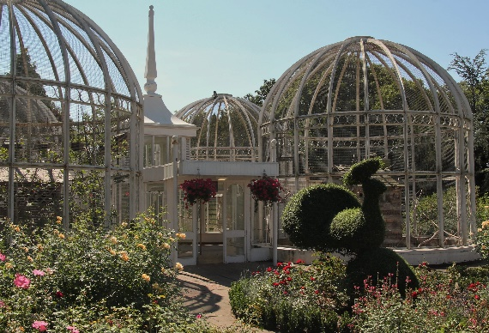
The gardening group has resumed its visits in 2022. Some regular favourites, such as Lea Gardens and Cascades were visited. Highlights included a trip to Brierley Farm at Ashover, where the homemade cakes were divine, and a Birmingham Botanical Gardens coach trip (illustrated). New members are always welcome to join us.
Liz Walker
Geology
The Geology Group has been busy throughout the year with a programme of visits and talks. The visits have included Buxton to view the various springs, Mam Tor to see the landslide, Lathkill Dale, Millers Dale and Tideswell Dale to look at the geology and the Goodluck lead mine. The talks have included an assessment of worldwide lithium deposits, landslides and the geology of Matlock.
Peter Clook
History 1
History Group 1 began meeting in person in May last year after over two years of Zooming. We were fortunate to find a new venue with space and ventilation and we agreed to test for Covid before each meeting to protect our vulnerable members.
At our first face-to-face meeting our theme was 'Living History'; our reflections on the pandemic and its place in history. We continued with the period we've been studying for over two years - 'The Victorians' - with talks and discussions on topics including The Match Girls' Strike, Isambard Kingdom Brunel, The Census, Lord Tennyson, The Battle of Rorke's Drift, Leslie Stevens, and Joseph and Sarah Paxton at Chatsworth. We ended the year with all contributing a short talk on an aspect of Christmas, continuing our tradition.
Janet Pidgeon
History 2
After two years of meeting via Zoom we began to meet in person again in March 2022. We continue to offer a hybrid Zoom/in person option, however, for those unable or reluctant to attend in person. We continue, notionally, in the 18th century – researching and presenting about anything worldwide. Occasionally we stray into other periods; we are not strict with ourselves but everyone does take responsibility for organising a session in turn. Topics have included: 18th Century Popes, William Wilberforce, The History of the Perfume Industry with Smellavision, and Lunacy and the use of Asylums.
The group meets monthly in members’ homes. Several people left last year and were replaced by new members. We could currently accommodate another member. See the website for details.
Helen Boocock
History 3
We have continued our monthly members’ talks throughout 2022 embracing all aspects of the nineteenth century. Subjects are ever more diverse with topics ranging from Bismark to the Haitian Revolution, and from the development of Barcelona to the first UK celebrity chef.
The group also organised a History Day in association with Matlock’s other u3a history groups. An invitation was extended to all u3a members and the day was well attended. Feedback was very positive and a future conference is under consideration. Social activities with partners are a feature of Group 3 and everyone enjoyed a festive meal get-together as well as a summer barbecue. A field trip is also planned.
John Entwistle
History 5
Nine meetings were held in 2022, with our remit the history and culture of Derbyshire and Yorkshire. Seven group members presented material, and we had three sessions led by visiting speakers. The group has expanded, and we have an attendance of between 20 and 30 members per session, the majority being people who live in St Elphin’s, where we are fortunate to be able to meet in The Orangery. Two members of our group presented material at the History Day on the theme of social history.
It's been a successful and lively year. Our first meeting was a planning and get together, aided by coffee and cake. Thereafter we have covered a vast range of history – Bronze Age stone circles to living through the 1984 miners’ strike from the perspectives of a mine manager, villagers near pits that were shut down, and the case for prosecuting miners. Not surprisingly mills have been the focus of several meetings – Richard Arkwright, Smedley’s Mill, and the impact of industrialisation on the people who worked in mills and potteries.
Roger Clough
International Dance
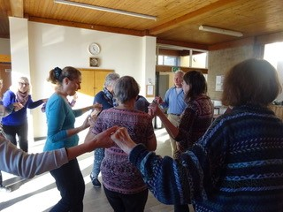
We are a group of ladies and gentlemen who enjoy learning and performing international dances. We meet most Friday mornings in the church hall on Smedley Street. We are a happy group and the music we dance to transports us to countries around the world. Mind you, our feet don’t always do what the dance music suggests! It is certainly good exercise, challenging to the brain and most of all really enjoyable.
We are one of the longest running groups in the Matlock u3a. Our leader, Janet King started us all those years ago but is now ably assisted by many others. We occasionally join other groups dancing at weekends and sometimes have visiting teachers teaching us other national dances.
Janet Husband

Local History
Once again we have enjoyed indoor and outdoor meetings, all of which have been well attended. Subjects started with ‘A potted history of religion with reference to the Matlock area’; an illustrated history of Beeley, then an illustrated talk on Bradford Dale. The following month we went for a walk in Bradford Dale; unfortunately the weather wasn’t kind, but the scenery was beautiful! The next month we were back inside with another illustrated talk this time on ‘The history of population from Matlock to Darley Dale’ with several old maps. Another talk was how Matlock and Matlock Bath looked in the late 19th and early 20th century, with old postcards. Again with pictures we learned about the history of Cromford. The group also took part in the History Day. The last walk was around Matlock when we had members of other u3a’s joining us for the 40th anniversary.
Susan Tomlinson
Mah Jong
The u3a Mah Jong group meets every Friday evening from 6 to 9pm, with a short refreshment break at the mid-point. This typically allows time for between 10 and 12 individual games, and socialising in the break. In 2022 the group met 48 times, with a typical attendance of between 6 and 12 members. We had a mixture of novice and experienced members and continued to welcome newcomers.
The group would like to thank group members Christine and Mike Tongue for the use of their premises, the Family Tree at Whatstandwell, in 2022. New members would be welcome to come along and join the group, whether novices or experienced players. In 2023 we intend to widen the number of venues to include members’ houses in the Matlock area.
Colin Davis
Mindfulness and Meditation
Following an initial meeting of interested people the current Mindfulness and Meditation group started meeting at the end of October 2022. The group has built on the experience of the Mindfulness group that ran briefly in early 2020. We currently meet fortnightly for one hour on the second and fourth Friday each month in Tansley Community Hall. We usually have at least 7 of our 15 members coming along to our sessions.
Our members have very variable experience of Mindfulness and/or Meditation, from complete novices to people who have meditated regularly for many years. What we have in common is finding a benefit in regularly completing a meditation practice together and in sharing our successes and struggles in keeping that practice going in our daily lives.
Judith Holt and Peter Hale
Rummikub
This new group plays a tile-based game for 2 to 4 players. It is a numbers game, but you don’t have to be good at counting to play!
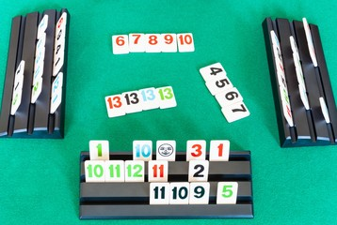
It is good fun and great exercise for the mind.
The group meets on alternate Thursdays during the winter months only between 2pm and 4pm in the Ostello Lounge in Matlock.

Merylyn Gamby

Saturday short walks
Unfortunately ill health and adverse weather conditions led to several walks being cancelled or postponed during 2022. Attendance at the walks which did go ahead ranged from 2 to 12, with walks covering areas from Calver to Carsington and varying between 2 to 4 miles.
Wendy Green
Singing for Pleasure
The Singing for Pleasure group met rather intermittently during 2022. We met as two small groups at the start of the year to minimise any possible Covid transmission. Then we did not meet for 3 months as our venue was unavailable. From July we met again as one large group, singing rounds, partner songs, traditional pieces, folk music and some more recent songs. In December we sang Christmas carols with a guest trumpeter. All year we have been ably accompanied by two pianists. Our main aim is enjoyment, and I think we achieved that in some difficult circumstances, thanks to the singers who turned out even when I kept the doors and windows wide open, and to the pianists who kept us in time and in tune!
Hazel Finch
Tap Dancing
The Tap Dancing Group met weekly throughout 2022, apart from August. In addition to regular revision of many previous routines the group has extended its repertoire further with new routines to ‘Strolling in the Park’, ‘Anything Goes’ ‘Ragtime’ and ‘Button Up Your Overcoat’. Two of these dances involve the use of canes which has added a new dimension to our routines, and new skills and coordination. We enjoyed a summer buffet in July on the hottest day of the year, before our summer break and a Christmas fuddle on 20th December.
Gwynneth Beck
Walking Group
Several members of the Walking Group have walked frequently and also led walks. It was rare not to have a volunteer to lead a route of 5-8 miles each week, and even in inclement weather walks were rarely cancelled! Walkers have enjoyed the varied terrain of Derbyshire, mostly within an approximate 15 mile radius of Matlock, along with companionship.
Karen Hale
Wildflower Group
The Wildflower Group met monthly from March to October at different venues around Matlock. We identified the abundant flora of Derbyshire and one coordinator has maintained an on-line data base of our sitings, including several photographs. We extended our searches to fungi, trees and lichens when flowers were dormant in the winter months. Approximately a dozen members participated in each outing, venues being chosen not only for their flora but also for their accessibility and car parking spaces!
Karen Hale
Wind Recorder
The Wind Recorder Group has 14 very active members. Last year we met weekly to enjoy playing familiar pieces but also ones with more challenge, which required a few weeks of practice, in a friendly and encouraging atmosphere.

Karen Hale

Webteam News
During the year the Webteam, with help from members and co-ordinators, have continued to improve and add to the website https://matlockareau3a.org.uk
This is now a ‘one stop shop’ for all information on Matlock Area u3a, the Groups, activities, events, membership and feature information. It is our shop window for potential members and a valuable source of information for existing members.
Our thanks go to the Web Team for all their hard work in building and maintaining a first-class website that we can all be proud of.

Coffee Mornings
As 2022 progressed, the popular monthly coffee mornings were resumed with a lot of behind the scenes work by members of the Committee, particularly Liz Mann who organised the events and Gill Needham who agreed to ‘have a go’ at providing Digi Desk support. Without volunteers for these events, they wouldn’t be possible.

Although 2022 continued to present challenges we built on what we had learned in 2021 and that gave us the ability to continue to learn, laugh, live.
Well done to all our members!
TRUSTEES OF THE MATLOCK AREA U3A AND MEMBERS OF THE MANAGEMENT COMMITTEE 2021-22

NAME | HOME LOCATION | COMMITTEE ROLE | ELECTED UNTIL
Gill Needham | Matlock | Membership Secretary | 2023
Brian Williamson | Matlock | Treasurer | 2024
Liz Walker | Darley Dale | Chair | 2023
Hilary Essen | Matlock | Group Liaison Officer | 2024
Roger Keeling | Wirksworth | Ordinary Member | 2024
Linda Wilson | Matlock | Business Secretary | 2023
Tracy Sims | Tansley | Ordinary Member | 2021
Stephen Bailey | Whatstandwell | Publicity Officer | 2024
Liz Mann | Matlock | Ordinary Member | 2024
OTHER | OFFICERS
Mike Frosdick | Matlock Bath | Web Team
Dave Puxley | Matlock | Web Team
Keith Bailey | Matlock | Equipment Officer
Diane Fosdick | Matlock Bath | Beacon Administrator

