**u3a** East Midlands Trustee

**Newsletter**

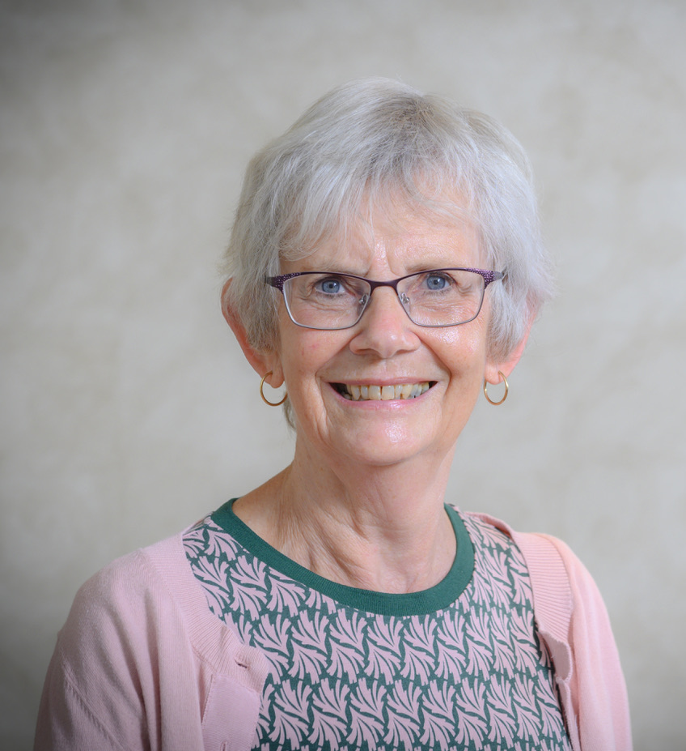

**September 2021**

I do hope that you have all had a good summer and kept well. Our activities are certainly beginning to feel more available and it is so good to be able to meet fellow members in person, not just on a screen.

**East Midlands Conference**

At the start of my 4th year as your Trustee, it was wonderful to be joined by around 90 people at Eastwood Hall last Wednesday. I am so grateful to the team of people who helped me to organise the first East Midlands Conference for over five years. We were fortunate to be able to hear both the national Chair and Vice Chair speak, and have received many very appreciative comments. I hope that the enthusiasm and ideas generated will continue to spread around the region.

**Future Strategy consultation**

I am sure you are aware of the ongoing consultation about our future direction. Since the launch of the Development Plan in 2019, life has gone in some very unexpected directions! The Trust needs to be sure that support is in place for the issues that matter to members *now* so I do encourage you to complete the survey. (Express Newsletter sent out Fri 1st Oct)

**Publicity and Recruitment**

Following on from the work of Chris Hartny-Mills, we want to continue supporting u3as to spread the word about the movement in order to recruit more members. Do put these dates in your diaries. Further information will follow.

We are providing 2 virtual sessions on Publicity and Recruitment:

**Wednesday 24th November 2-4pm *or* Monday 29th November 2-4pm.**

The purpose is

1. To encourage u3as to identify Publicity as an integral role within their committee: the role to be ongoing local profile raising and recruitment of new members.
2. To entice some individuals to support PR activities within the East Midlands and to work with other PR and Media Advisers across the UK.

The sessions will include marketing ideas and materials, items from the Pathfinders toolkit and examples from u3as.

According to recent (pre pandemic) analysis done by Ed Link, the East Midlands has the highest density of members as a % of people aged 65 or older in the country. Whilst we should feel very proud of this we are still only talking about just over 7% (compared to under 2% in the NE) so there is still plenty of opportunity for recruitment.

**40th Anniversary**

At the end of our Conference Michaela Moody, Vice Chair of the Third Age Trust, told us about the plans that are being made for the 40th Anniversary of the u3a movement, next year. These include the Quilt competition and Wood, that have already been publicised, but also intergenerational debates, round table discussion involving our founder, Eric Midwinter, and a u3a week. Michaela would love to hear from you with comments, more ideas and slogans. Please email her at

michaela.moody@u3a.org.uk

**u3a Day 2022**

The TAT Board has agreed that for the next 5 years u3a day will be during the week containing 21st September. Next year this is from 17th – 25th September. This should allow u3as to hold events on the day that suits their community best.

**Hybrid Meetings Facebook page**

There is a new closed Facebook page called u3a: Let’s talk tech, which will provide the opportunity for the exchange of information about such things as Hybrid meetings.

[https://www.facebook.com/groups/1002726203847774/?ref=share](https://eur02.safelinks.protection.outlook.com/?url=https%3A%2F%2Fwww.facebook.com%2Fgroups%2F1002726203847774%2F%3Fref%3Dshare&data=04%7C01%7Cjean.hogg%40u3a.org.uk%7C549d0ced88e44d72cb9108d9840f3025%7C8ba44ae7c27743f69ffd1eeac5a8c804%7C0%7C0%7C637686023033446678%7CUnknown%7CTWFpbGZsb3d8eyJWIjoiMC4wLjAwMDAiLCJQIjoiV2luMzIiLCJBTiI6Ik1haWwiLCJXVCI6Mn0%3D%7C1000&sdata=KaDfgH87ZbYINEqje%2Bsj36JoZvxRYQ%2FnWLLSCFzTjww%3D&reserved=0)

Another date for your diaries: Next TAT AGM – 6th October 2022

I can be contacted on: [jean.hogg@u3a.org.uk](mailto:jean.hogg@u3a.org.uk) or phone: 0744 322 1688



**Jean Hogg** Trustee East Midlands

[www.eastmidlandsu3as.org.uk](http://www.eastmidlandsu3as.org.uk)

The Third Age Trust

Tel: 0208 466 6139 [www.u3a.org.uk](http://www.u3a.org.uk)

156 Blackfriars Road, London, SE1 8EN

Registered Charity: 288007 Registered Company: 1759471