Appendix 1A: Annual update of membership form

- Membership Secretary needs to update Word version of Membership form. If they cannot find one, there should be a previous version in Word format in the “Worddocumentarchive” folder of Media Folders. The final version should then be saved as a PDF and sent to the Web Team.
- Download the PDF form to your Desktop.
- Go into website as administrator and go to Media Library Folders in the Dashboard
- Open Management Committee folder, then Membership sub-folder
- Click on “Choose File” under “Drag & Drop Files Here” and select the PDF file from your desktop. The file details should appear to the right of the box. Then click on “Upload Image”. An image (box) for the file should be added to those for the Membership folder
- Click on this box. A new screen should appear showing details of the PDF file now stored in the Media Library

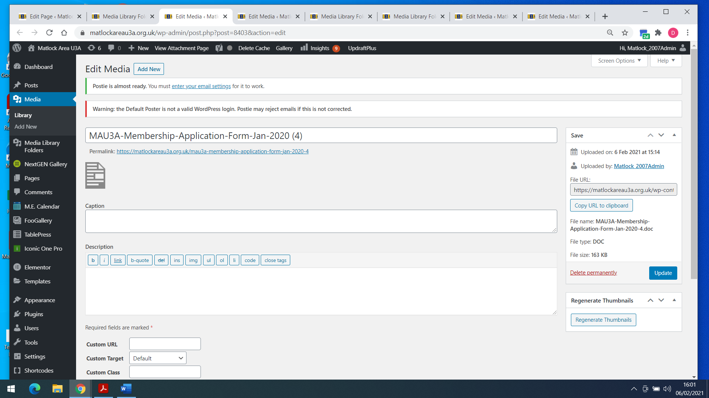

- In the right hand panel (“Save” heading), click on “Copy URL to Clipboard”, then close the screen
- Now go to the “How to Join” page and open in edit mode
- Go to the end of the 1st section “The form can be downloaded by clicking here.” Select “here” and a small link edit screen will appear
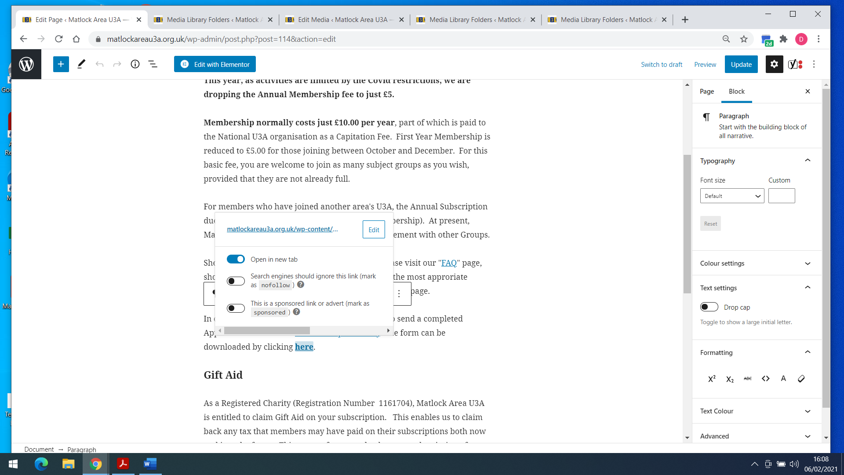

- This shows the link to the old membership form. Click the “Edit” box. The field “Open in New Tab” should appear in blue. If not, check this field button so that it does. Now select and delete the old link address and paste in the new one. Then hit the “” (submit) arrow.
- Don’t forget to “Update” the page.

Appendix 1B: Remove a subject group

- Within the Dashboard, click on M.E. Calendar, All Events. You should see the following screen, listing all the types of events
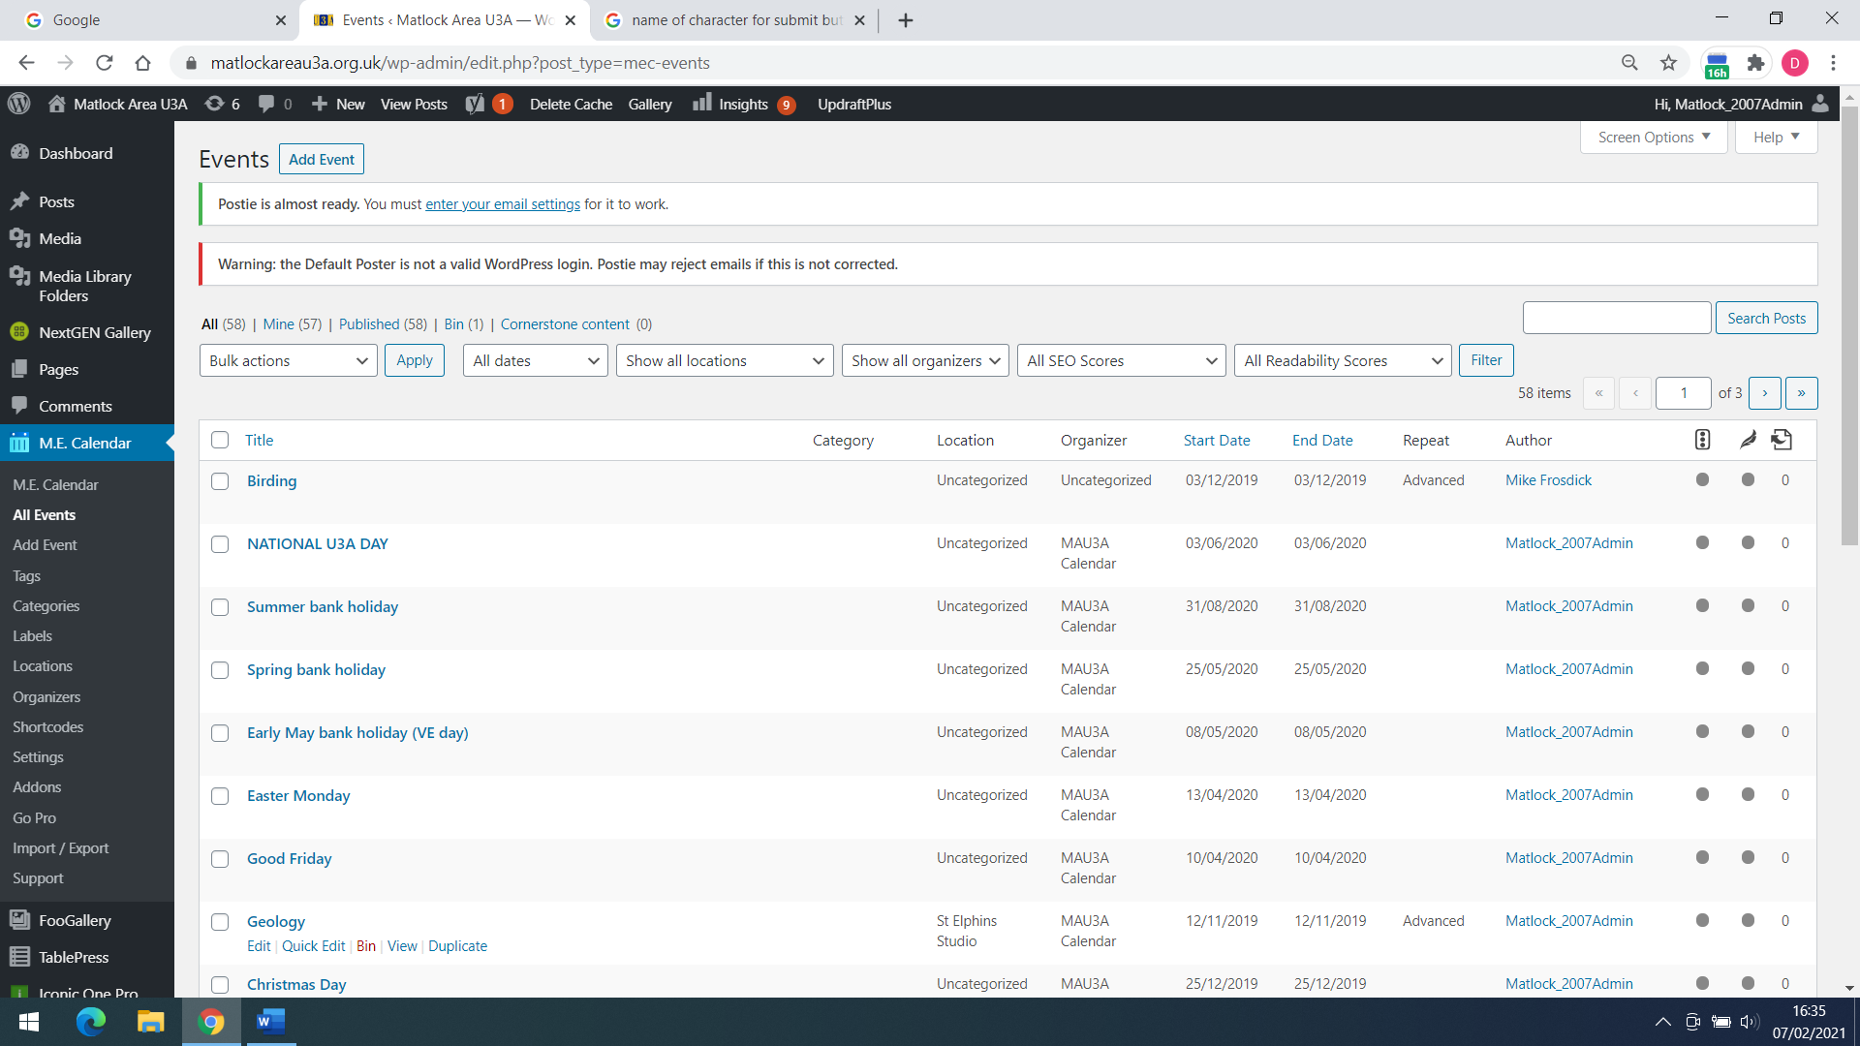

- Select the group that you wish to delete (left hand box) and click on “Bin”. This has the effect of deleting all the events for that group.

- Now Click on Tablepress in the Dashboard, All Tables. Select Table 17 – MAU3A Group Meeting Days and choose “Edit”. Select each entry for the group to be deleted (one entry for every meeting in the month) and delete the text from the table. Save the changes.

- Now, still within Tablepress select Table 3 – Group List 2 and choose “Edit”. Find the row number corresponding to the group to be deleted (see last column) and click in that box on the left hand side (a tick appears)
- Scroll up to the box labelled Table Manipulation and click on the “Delete” button. Again save the changes.

- Now go to “Pages”, “All Pages” in the Dashboard. Select the page for the group to be deleted and click in that box on the left hand side (a tick appears)
- Click on “Bin” and save the changes.

- The content for the group has now been removed from the main website. However, we still need to delete the generic e-mail for the group, which is done in the Ionos website.
- Go to ionos.co.uk and login using our account number and password. You will see a screen similar to this one
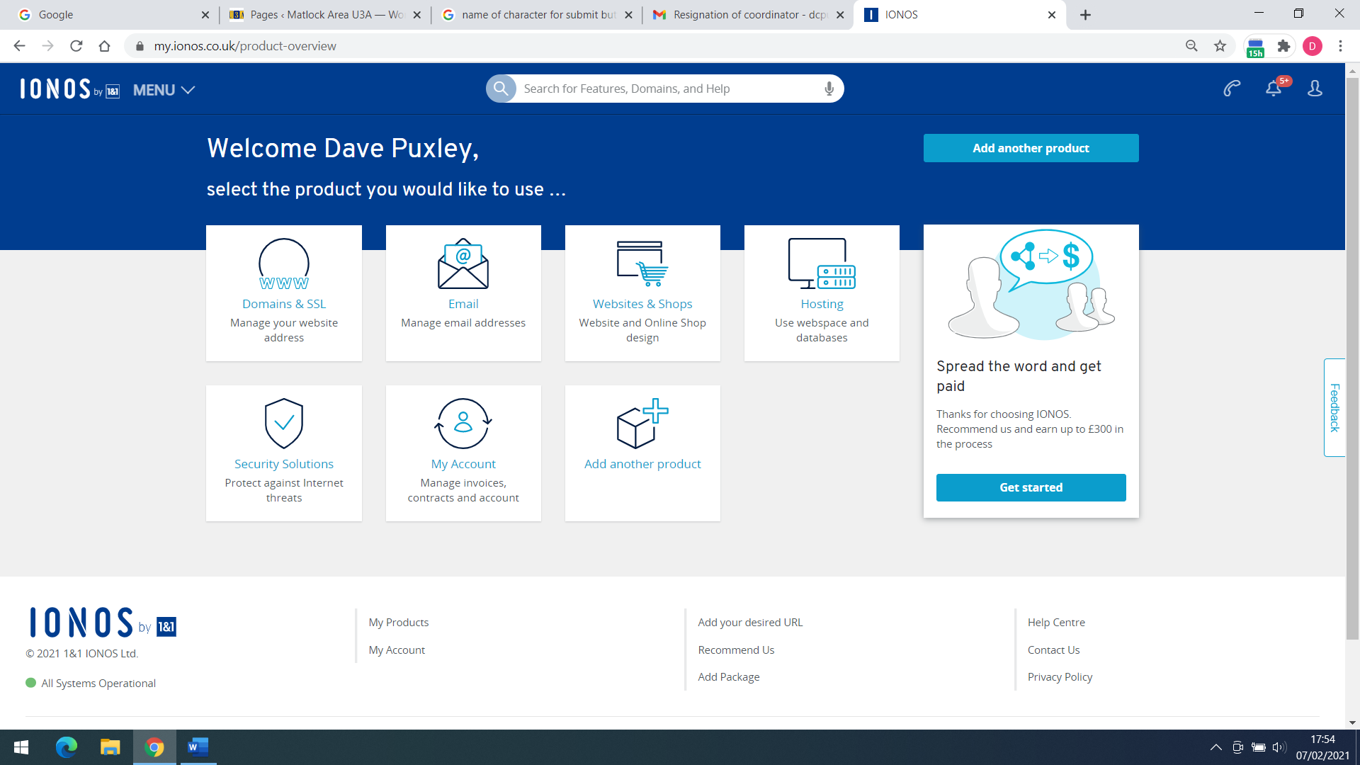

- Select “Manage email addresses”. You should now see list of e-mail addresses for each group. Find the one to be deleted and click on the gearwheel on the right hand side. Then click on “Delete”.

Appendix 1C: Change group co-ordinator details or meeting arrangements

- Go to Tablepress in the Dashboard
- Open Table 30 – New Group List in edit mode
- Find the group whose co-ordinator is changing
- Edit the fields for the co-ordinator name and telephone number
- Save changes
Or
- Edit the fields for the meeting day and time
- Save changes

- To change meeting arrangements ONLY
- Open Table 17
- Edit day / time details for group as required
- Save changes

- To change meeting arrangements ONLY
- Within the Dashboard, click on M.E. Calendar, All Events.
- Select the group in question and then “Edit”
- Scroll down from the group name to the Event Details section

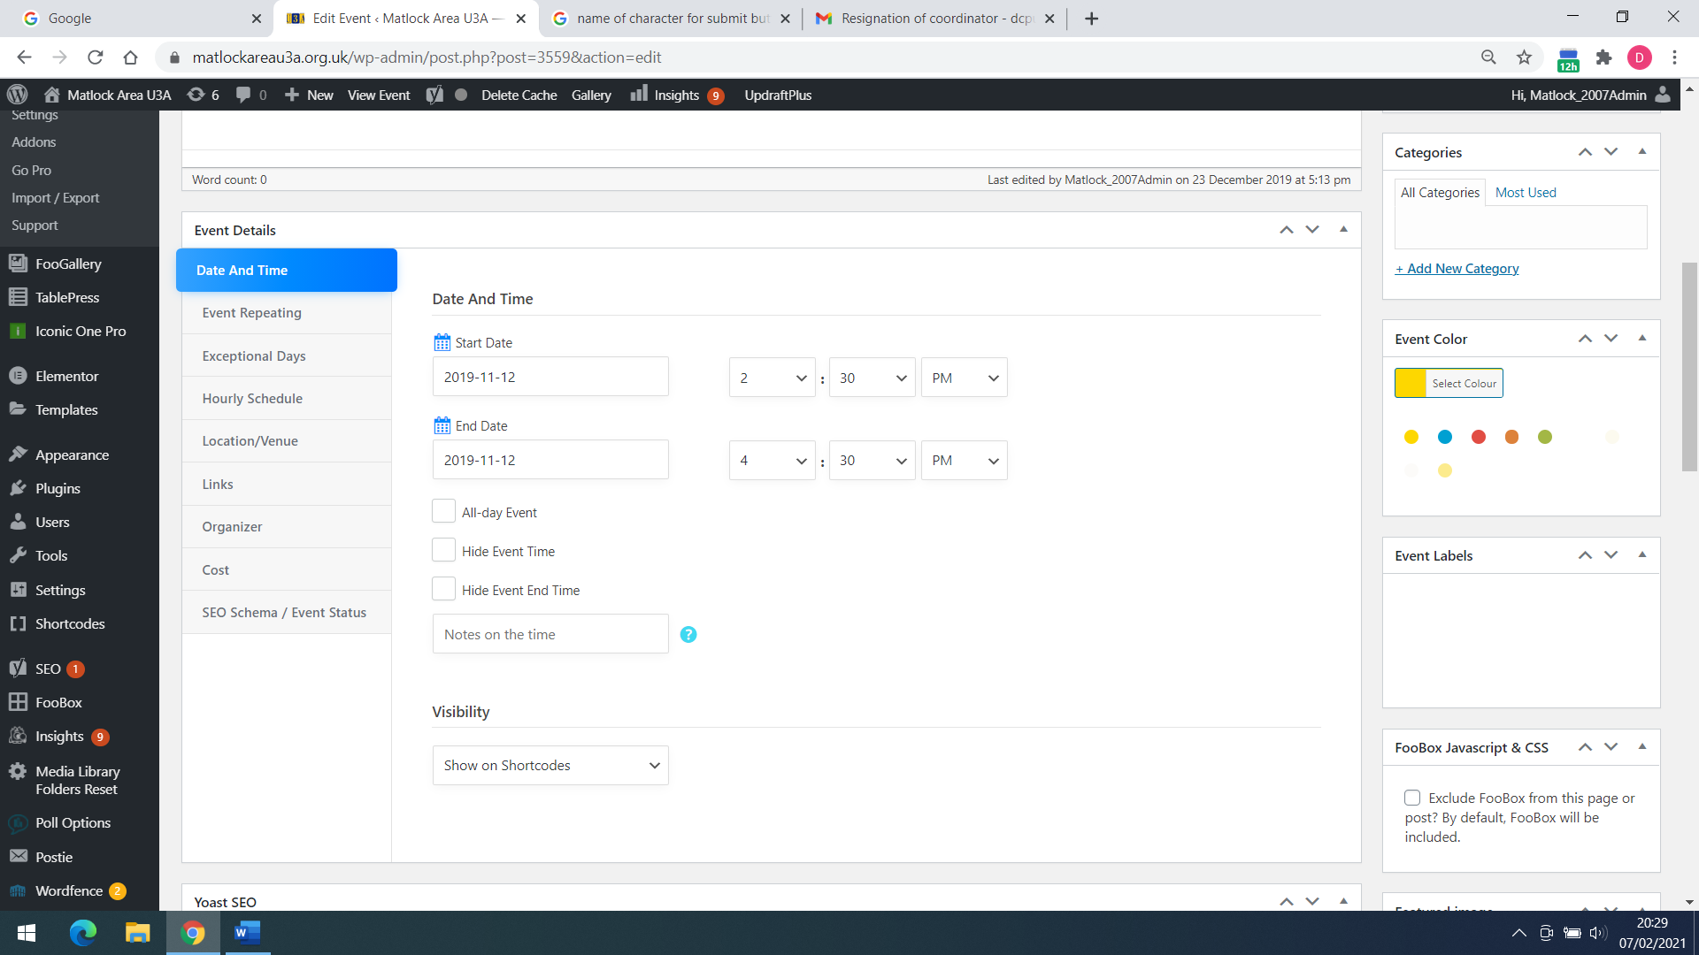

- From the blue panel on the left, you can select and edit the date and time (for a single event), repetition details, location, link to group page, etc. Then click “Update”

- However, we still need to change the Group Page to show the new meeting details or co-ordinator contact details
- To do so, go to “Pages”, “All Pages” in the Dashboard and select the Group Page in “Edit” mode.
- Change the co-ordinator name if required. Remember that the personal phone number of the co-ordinator (if this is changing) needs to be encoded. To do this, the telephone number must be enclosed by two sets of square brackets as follows:
[encode]01234 123456[/encode]

- Finally, we need to change the co-ordinator’s personal forwarding e-mail address. For this, login to Ionos as described in Appendix 1B. Then as before select “Manage email addresses”. You should now see list of e-mail addresses for each group. Find the one to be edited and click on the gearwheel on the right hand side. Now click on “Settings”
- Click on the “Forward” address and edit it to show the new co-ordinator’s personal e-mail address. It may be necessary to add the new one before removing the old one.

Appendix 1D: Add a new subject group
- We assume that a new group has been formed, has a co-ordinator and an agreed meeting day and venue

- Firstly, create a generic e-mail address for the new group. Login to the Ionos website and go to the e-mail management option as described in 1B and 1C
- When the “Email Addresses” page opens, click on the blue button labelled “Create Email Address” in top right corner. The group address needs to be of the form groupname@matlockareau3a.org.uk and the forward address is that of the new co-ordinator

- Create a new Group Page according to the chosen wording of the new co-ordinator. Ensure that the new co-ordinator’s telephone number is encoded (see Appendix 1C) and that you have used the new generic group e-mail address. Don’t forget to publish the new page and to save any changes.

- Send the new co-ordinator the password for the password protected areas (MAU3Amau3a). This is also a way to test out the new e-mail address

- Add the new group to the Group List. Select Tablepress, “All Tables” in the Dashboard and open Table 3 – Groups List 2 in edit mode. Go to Table Manipulation above the tables list, and where it says “Add 1 row(s)”, click the “Add” button.
- Now enter data in the new row at the bottom for the new group in columns B, C, D, E and F. Click on “Save Changes”
- We now need to add a link to the Group Page from the table in column A. There are two ways to do this.
- Either – In a new window, go to the new Group Page and copy the web page address. It should be of the form matlockareau3a.org.uk/newgroupname. Now go back to the Tablepress window and go to Table Manipulation above the tables list again. This time click on “Insert Link”. Then click on the cell in column A for the new group (the only column still empty). A new small screen appears.

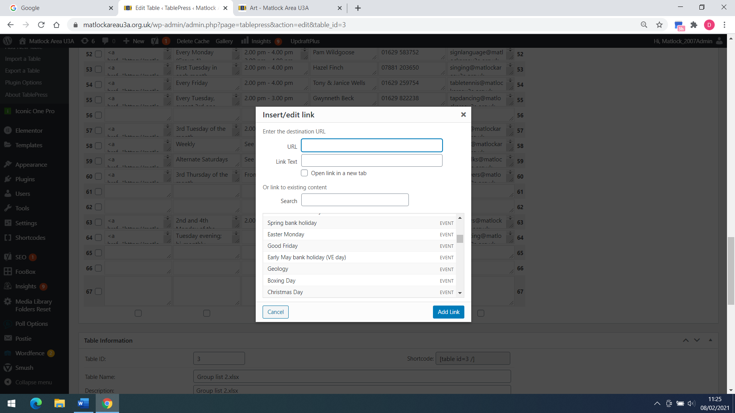

Now paste the copied group page address into the “URL” field and type the name of the new group into the “Link Text” field. Then click on “Add Link”. Save the changes.
Or – click on “Insert Link” in Table Manipulation as described above, selecting the cell in column A. Then scroll down the list of pages in the small screen shown above and select the new group from the list. These fields are then populated for you. Again click “Add Link” and save the changes.
- Check that the new group appears on the Groups List page (you may need to refresh the page as sometimes a cached page appears that does not contain the latest update). Check also that the link to the Group Page works.

- Now Click on Tablepress in the Dashboard, All Tables. Select Table 17 – MAU3A Group Meeting Days and choose “Edit”. This contains a monthly plan of group meetings, listed by week in the month (1st, 2nd, 3rd, 4th or last) and AM or PM. You now need to add the new group to this table at the appropriate places. If it is to meet more than once a month, you need to make an entry for each occasion. This may be easy if there is an empty space where you need it. If there is not, then you need to add a new row to the table to create a space for it. Please note that there is a blank row between weeks of the month that needs to be preserved in the table. Long group names may need to be abbreviated. If you do need to insert a new row, go to the row below and select it in the left hand box. A tick appears. Now go up to the “Table Manipulation” area and “Selected Rows”. Click on the “Insert” box. Save the changes
- The new group should now appear on the “Groups by Day” page

- The next task is to put the meetings for the new group into the MAU3A calendar. Go to the Dashboard, select “M.E. Calendar” and then “Add Event”
- In the “Add Title” field at the top, insert the name of the new group. Now scroll down to the “Event Details” box. If it only shows a single line, click on the “Event Details” field to open up the full form
- Under the “Date & Time” section enter the date and start / finish times of the first meeting for the new group. Now select the “Event Repeating” section and check the “Event Repeating (Recurring Events)” box to the right. Options now appear to define meeting intervals. In the “Repeats” box select the dropdown and click on “Advanced”. This makes it easy to specify meeting days within the month by checking them.
- In the “Ends Repeat” box, select “Never”. This means that the calendar is good for future years too without any additional work
- We tend to leave the exceptional days field blank. This field is intended ensure that no entries occur for days like Christmas Day. However, it is easier to delete entries manually as appropriate.
- The “Event Location” field does need to be completed. It can be entered manually but you may find the necessary location already exists in the dropdown box.
- Make sure that you “Publish”.

- All the meetings for the new group should now exist in the Calendar.

